**ABC Recording Form Directions**

**KEY POINTS**

* ABC Observations are used to *confirm the accuracy* *of the teacher interview*
* Designed to be **individualized** for the student based on interview results
* Complete all of the information at top of the form before the observation.
* Complete the shaded portion with summary information from the interview. This is what you will be looking for in the observation.
* Use the interview summary statement to guide **when and where** to conduct ABC observation
* Start by recording the behavior, then write what happened directly before (Antecedent) and after (Consequence) the behavior
* Immediately after the observation check boxes that correspond with activities, antecedents, & consequences recorded
* Summarize results & compare with the interview summary statement

**REMINDERS:**

**Antecedent** = what happens right before the behavior that triggers the behavior

**Behavior** =the observable, measurable behavior of concern exhibited by the student

**Consequence** = What happens immediately following the behavior that reinforces the behavior of concern. Remember, this should be viewed from the student’s perspective. *Tip: Be cautious not to put the student’s escalation behaviors in the consequence box (these belong in the behavior box) – think about environmental elements that change and what the student gets or avoids.*

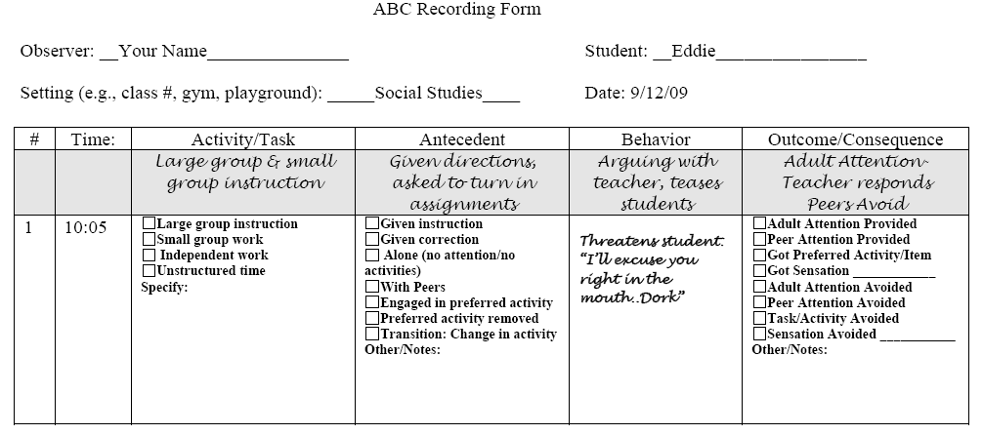

**Before observing**

1. Complete the shaded portion based on the interview summary.
   1. When/Where will you observe her?
   2. What behaviors will you be looking at?
   3. What Antecedents (triggers) will you be looking for?
   4. What Outcomes will you be looking for?
2. Schedule observation during routine (time/place) identified as most problematic from the interview
3. Record the date/setting/time of observation.

**During Observation using the ABC Recording Form**

* 1. Always start with recording the behavior first—be as specific as possible
  2. Write the activity/task occurring in class
  3. Write the Antecedent that occurs before the behavior
  4. Write what happened right after the behavior occurred in the Consequence box

**During or Immediately after the observation**

1. Check the boxes that correspond with the activities, antecedents, & consequences you recorded.
2. Summarize Results from ABC Observation
3. Complete the shaded box in the bottom of the ABC recording form based on the most frequently observed ABC’s
4. Compare summary statement from ABC observation with that from the interview with staff
5. Rate how likely it is that this Summary accurately explains the identified behavior occurring (1-6)?

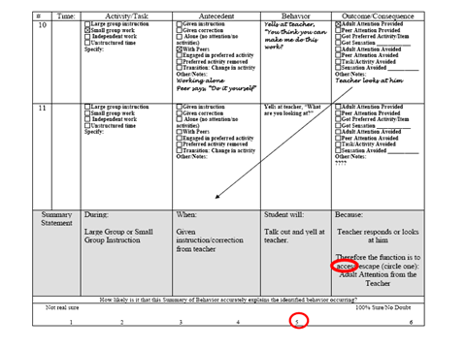

**Determining a pattern of behavior:**

You may be convinced the summary is correct if…

you have observed at least 5 instances that verify the interview summary

OR there is a 3 to 1 ratio of verifying vs non-verifying observations

If data from observation matches interview SUMMARY OF BEHAVIOR then you can confidently conclude with a final summary statement.

If data from observations do not match interview behavior summary or you are not convinced….

-Do another ABC observation

-Interview other staff that interact with student during target routine

-Collect other sources of data



**Definitions of Checkboxes on the ABC Form:**

Activity/Task

* Large Group Instruction- All students in the class are attending to the same person/event (e.g. teacher is lecturing, working problems out on the board)
* Small Group Work- Students are working in smaller groups.
* Independent Work: Students are working by themselves (e.g. worksheet, individual tasks)
* Unstructured Time: No specific instruction is given by teacher (e.g., transition)

Antecedents (Before the student engages in the behavior)

* + Given instruction: teacher gives a task or assignment has been given.
  + Given correction: teacher corrects the student’s incorrect response or behavior.
  + Alone (no attention/no activities): student is alone with no activities or attention provided.
  + With Peers: Peers are in proximity to the student.
  + Engaged in preferred activity: Student is doing something they enjoy.
  + Preferred activity removed: activity is removed.
  + Transition/change in activity: current activity is changed

Outcomes/Consequences (After the student engages in the target behavior)

* + Adult Attention: teacher talks to student in a negative, neutral, or positive way
  + Peer Attention: students talk to or respond to student’s behavior in some way (e.g. laugh, talk back)
  + Got preferred activity/item: student gets something they like (e.g. toy, candy) or activity they like (e.g. coloring, listen to music)
  + Got sensation: student receives sensory input (e.g. tactile objects, sounds, etc.)
  + Adult Attention Avoided: student avoids attention from teacher
  + Peer Attention Avoided: student avoids attention from peers
  + Task avoided: the task is removed
  + Sensation avoided: student avoids sensory activities (e.g. loud sounds, textures, etc.)

**Tips:**

One outcome/consequence may be a new antecedent/trigger

